FSWG 11 May 2024 – Membership Meeting



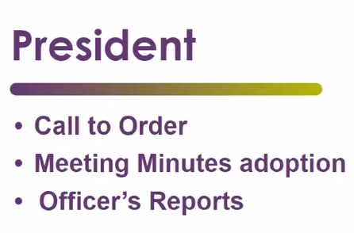
Meeting Minutes for April – minutes voted and adopted


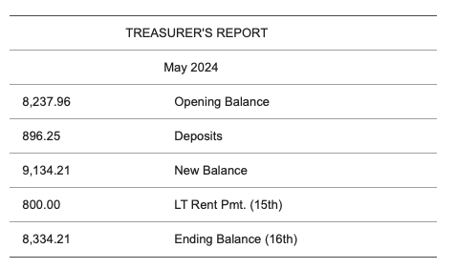

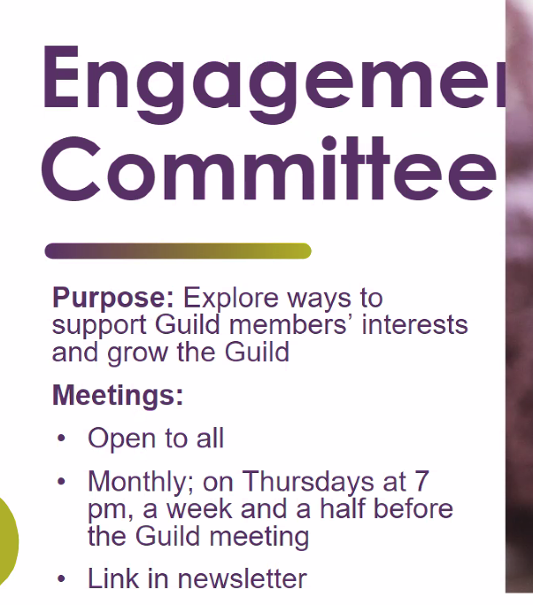
Next meeting Thursday May 30 at 7pm EST

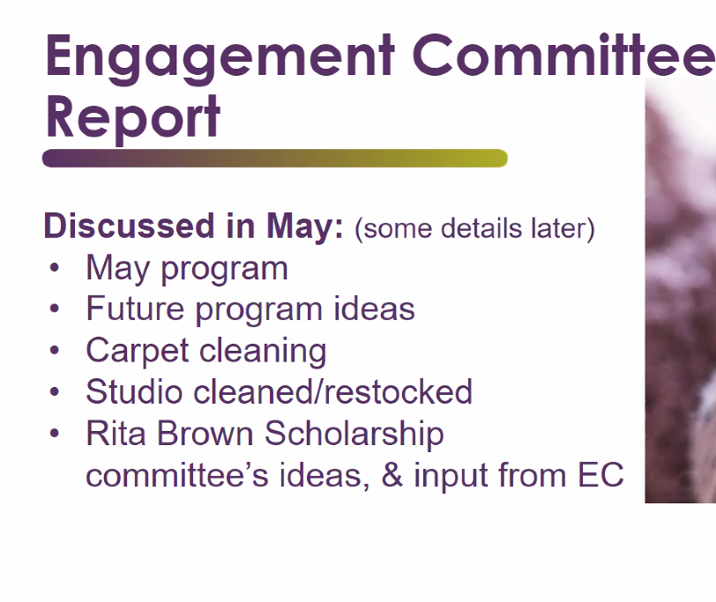

Linda George – they are looking for a place to stay
State Parks seem to be the best There have been a lot of roadblocks.
Need to know if people are willing to share rooms, share beds, or sleep in bunk beds
Bell Isle House seems to be the best option for a home.
Something else they are exploring is staying at a hotel with conference space.
Some members went to Turf Valley Resort – they have places with a good amount of space and nice common/shared spaces
There is also a monastery in MD that might be possible
A few people chimed in with other ideas that they will pass on to Linda.


The committee would like to wait until they see how much is raised at the retrospective before they make further plans.
If enough is raised, they would prefer to make a self-perpetuating fund.
The idea is this scholarship could be applied for and used by individuals for classes that improve their fiber art skills. They would then come and share this with the guild.


Toni – getting the documentation to file the report. Then the executive board will review the info to make sure everything is correct


There is a special door prize – so be sure to pick up a door prize ticket.

Lesley – they tried sharing photos from guild events and it didn’t go so smoothly so a new plan – If you have photos from an event let Lesley know and she will create a file and send you the link. From that link you can then upload your photos. This is for Guild only use.
Anything that is released publicly – like on the website or Instagram etc.. there cannot be any children in the image – unless there is a photo consent release.
It was suggested we have a way for adult guild members to opt out of having their photo shared. We will have a form for all guild members to sign – and each person can opt in or opt out of having their image shared.
See Lesley for tech support if you need help with this
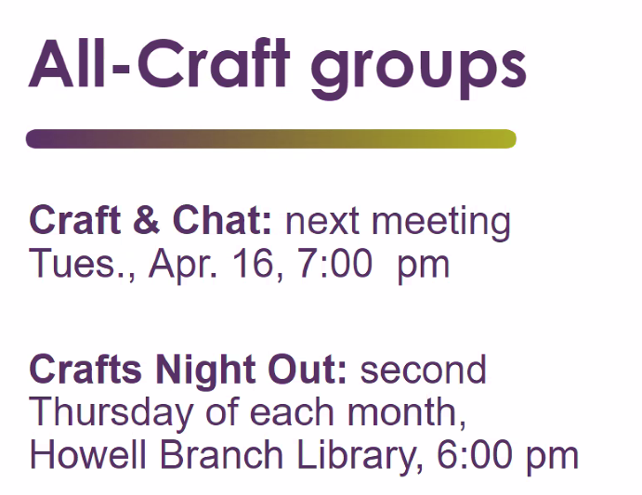
Craft & Chat – will be by zoom. Watch for the link to go out
Crafts Night Out – they are looking for ways to get more involved. It might be at a bad time. It is listed and advertised in the same way as all other library events. The library closes at 8 and they need all meetings to wrap up by 7:30. They use to have a robust arts and craft group prior to 2020. The librarian will look up those records so the crafts night out group and see what was working well for that other group

The PDF newsletter is slimed down. It is much faster to create. Takes about 2 hours once a month.
The Guild is in need of a dedicated person to create this newsletter – let Aileen know if you’d like to help out
If you are not getting the newsletter, contact Aileen AND Lesley:
Aileen - specedt1@gmail.com
Lesley - pixie91075@gmail.com

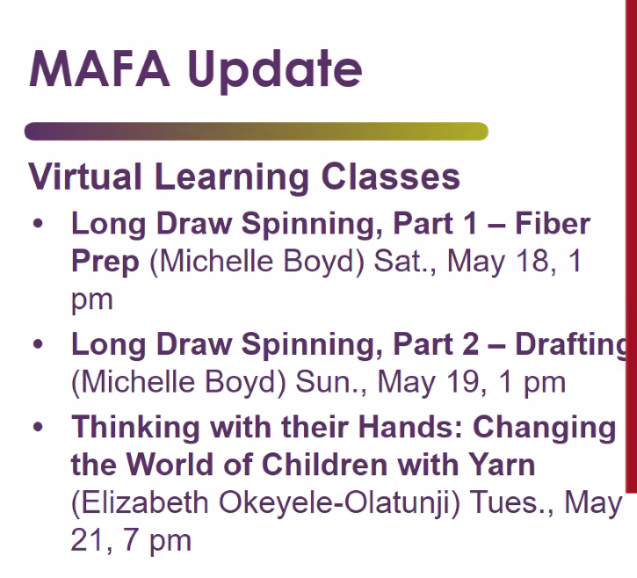
Diann K – is taking on the MAFA rep duties – THANK YOU!

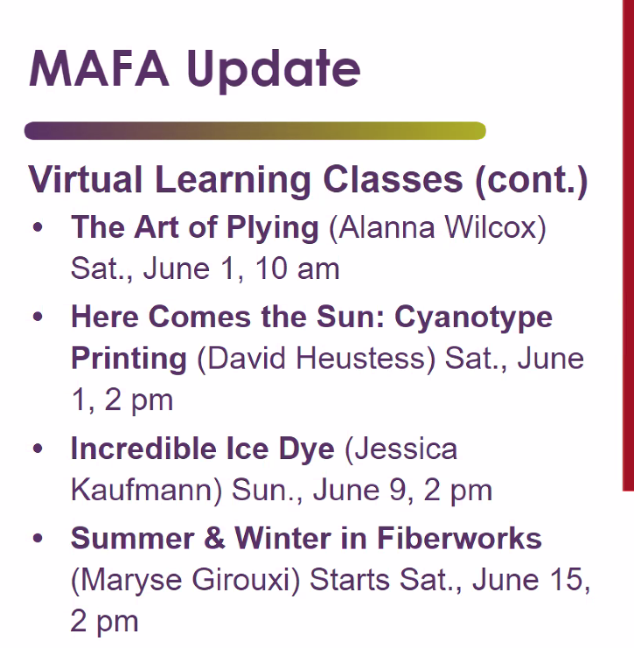

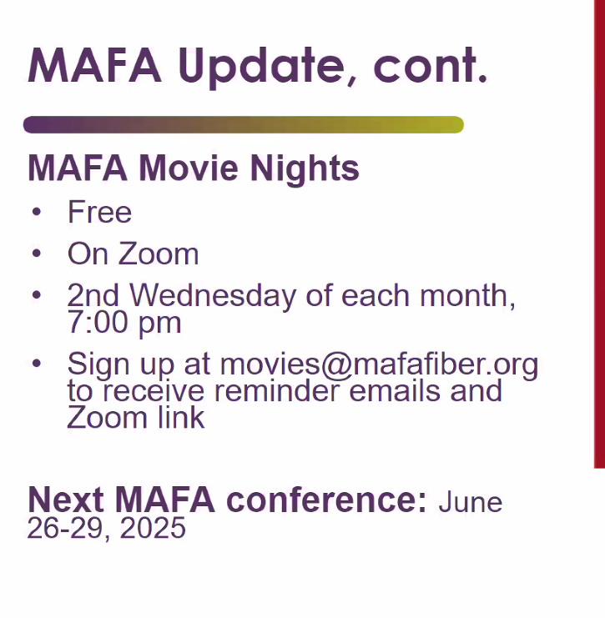
If you would like to host a remote fiber related meeting or event you can contact MAFA and they will host the Zoom meeting for you. There is no time limit to your meeting and it can be recorded for later viewing.

Thank you to those who brought the snacks today
Next month is filled but the rest of the year needs volunteers – paper sign up is going around.
Judy will check if we can use her community club house again – in September for the picnic potluck yard sale
There is a full set of supplies – table covers, paper plates etc

Chris and Margarete are our newest members – WELCOME!
Mary made a nice display for the name tags – Thank you!

We need people at the Maker Faire to demonstrate – its 4 hours, indoors, anything you’d like to demonstrate.
There is a sign-up sheet or contact Aileen or Kara if you’d like to attend. Can set up as early as 9 am

Nov 2nd and 3rd – the Caledon Art Festival – we need to be well represented and they really want us there. This festival is a big deal. We need to have our marketing material all squared away.
Port Royal – still waiting for all details but if interested let Kara know
disAbility Center – in the fall, indoors



The Clydesdales is the same day as the Guild Holiday meeting.
We hope to hold the guild holiday meeting at a church

If you have any ideas for program let Kara know. We need new ideas!!
On June 8th there will be a short guild meeting and then we’ll all go out and knit. If you don’t know how to knit go with a buddy that does. This meeting will not have a zoom link for remote viewing.
Food Co-op would be a good place to knit in public.
Snack baggies to grab and go – no show and tell


Let Judy know if you are intered in selling in the guild space and she can help get you set up.

Abby – she need images and info to help in her creation of the digital learning resources
She’d love an assistant. Contact her if you’d like to help.
She’ll take any images you have. Reach out!!
A day dedicated to take photographs of step by step how to and such would be really good.
The is an individual who has professional photo set up. Lyneette Reed


Lynette Reed – is our Liaison –
The door to the exterior is going to be fixed. Until this the guild does not want to put in money for new carpet. With Georgette moving out her space Denice will be moving in. They cleaned that spot of carpet and the open common space. It made a huge difference. So, they want to clean the main/common areas. As looms are moved, we can clean it section by section. It made a huge difference in cleaning the carpet.
Also – Georgette is no longer teaching classes.
Fran teaches knitting and weaving.


This is going on now through the 17th. Individuals can by a ticket and rank which items they would like and it is “raffled” off. Spot by and see what is on display.
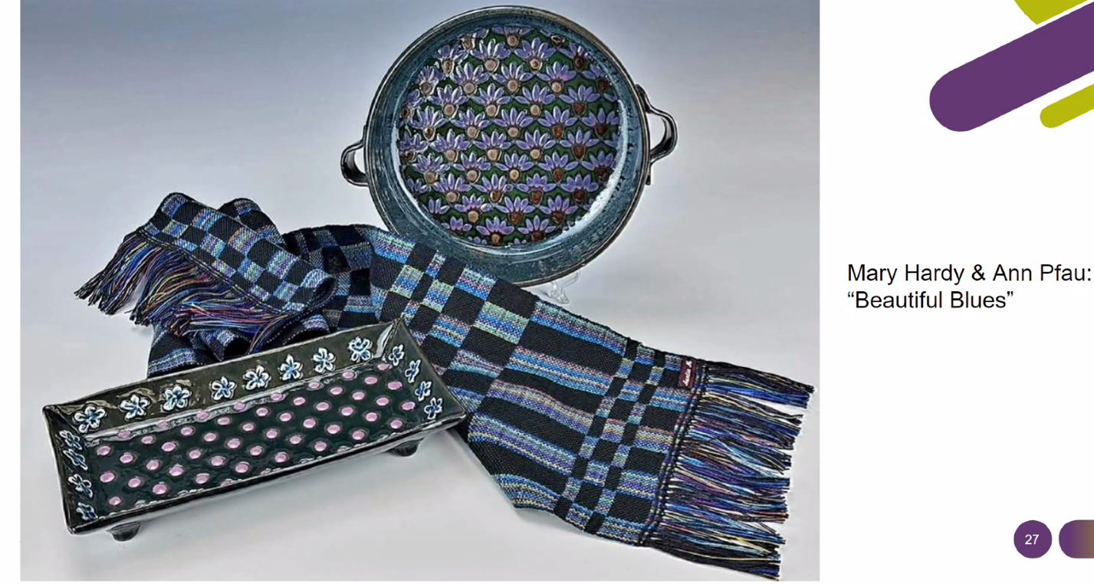
An example – Mary teamed up with a potter

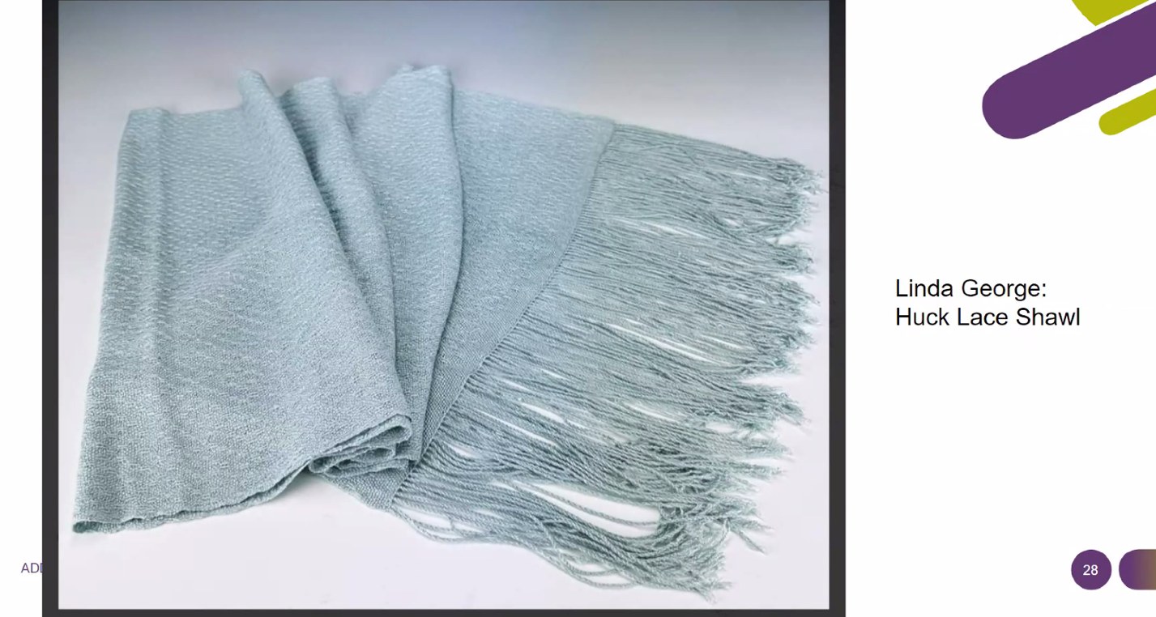
Silk shawl with clear beads on the fringe

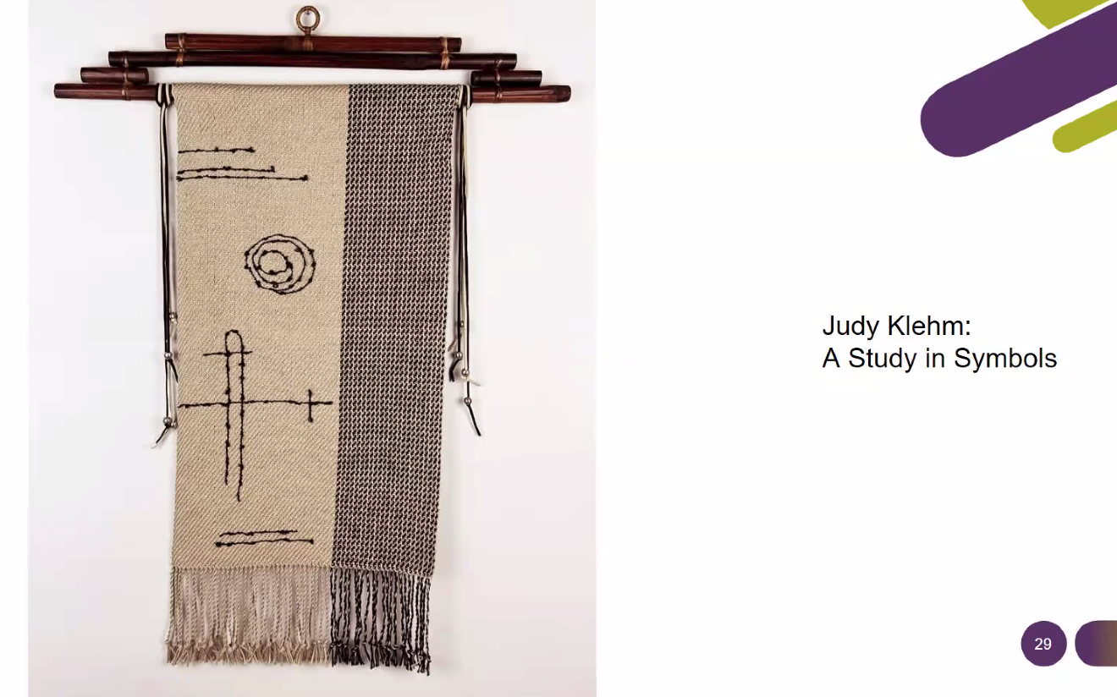
Woven with symbols that “just came to me”


Marbling
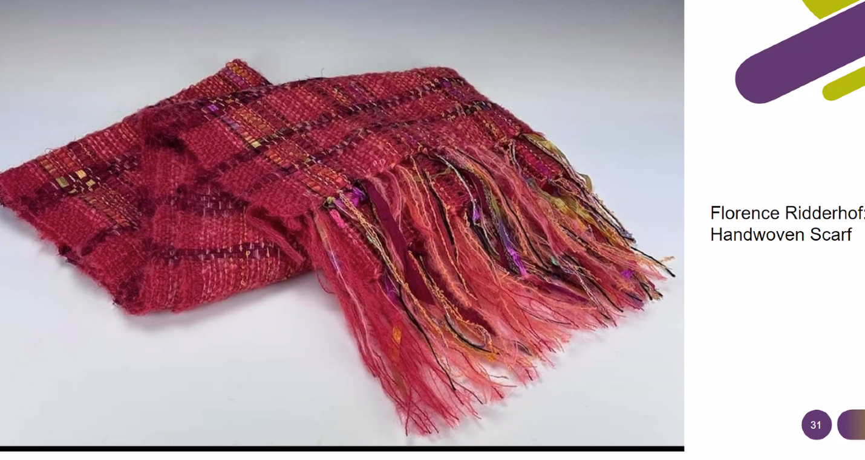
The patron show is a huge fundraising for Liberty Town. When our members participate it show our support for LT

We need individuals to monitor the social media site/groups
In our Ravely group we can post things to sell like yarn and such. You can also sell items on the guild website – these would be fiber art supplies, not finished products. To sell finished products at the guild space talk with Judy.
Sign up on the website for an email that will give you updates when new posts go on up on our website


Chris and Margarete are our newest members – WELCOME!
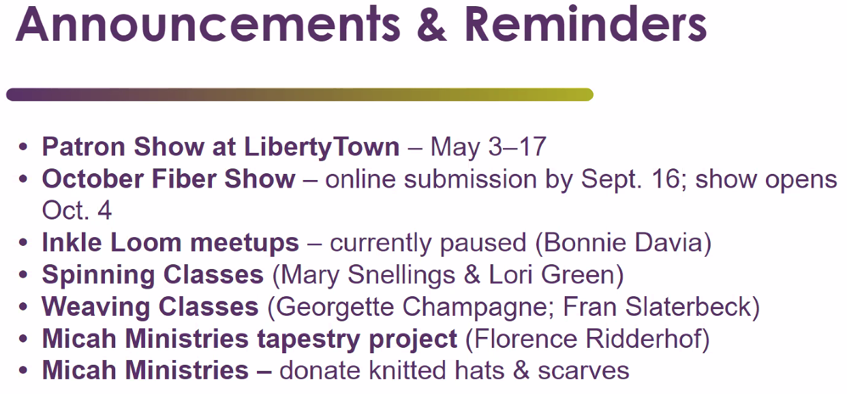
Update – Georgette is no longer teaching weaving
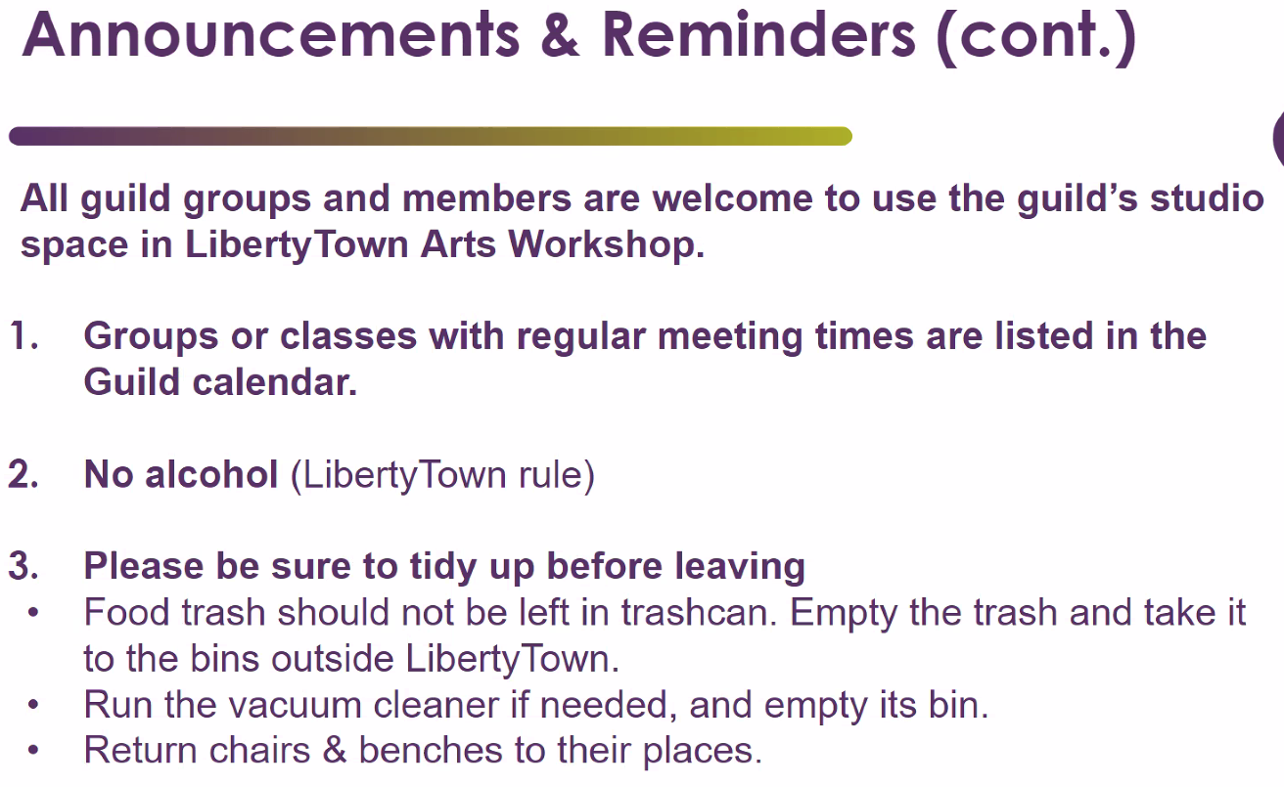
Some equipment is stored at members homes – but look at the list, check out the item you want to use, and if not in the guild space, coordinate to pick it up from the home it is stored at
Abby donated circular knitting looms

